|  |  |  |  |  |  |
| --- | --- | --- | --- | --- | --- |
| Date | Sept 21, 2022 | | | Tester Name | Alyssa Johnson |
| Environment | Penfax - Test | | | Login used |  |
| Operating System | Select OS | Version: | Update: | | |
| Software Used | Select Software | Version: | Update: | | |
| Select Software | Version: | Update: | | |
| Release version | 22.3.0 | | | | |
| Title | E 23.04 & 23.04b | | | | |
| Test Type | Regression | | | | |
| Test Scenario | Process Tax Exemption Indexation Batch | | | | |
|  |  | | | | |
| Expected Results | JEA Instructions:   * Add the "Tax Exemption Indexation" batch through Batch Processes * Enter the tax year for the new instructions" * Verify that the batch ran successfully * Verify that for the member's found in Step 1's precondition, the tax instructions were updated/added correctly as per the new year and the exemptions on the previous tax instruction   Confirm 5 members who are in VPB that require tax updates, that it updated correctly (in tax instructions and in benefit recipient and that all the details match).   * Test at least one member with “additional amount to be deducted” in tax instructions. * Test at least one member with claim code 0 in tax instructions * Find a VPB member not from the tax batch list (from the app or member search) to confirm their instruction was updated correctly   Note: *If any VPB members have a TD1 type of “basic” and not “advanced” there isn’t supposed to be a new tax instruction created. If any members do not have funds in their investment account, a new tax instruction will not be created. Any other member should have a new tax instruction when this batch is ran.*  23.04b   * Test members with more than one plan & ensure the tax instructions get attributed to the proper plan in benefit recipient * Confirm that a member without a retirement/income in benefit recipient still has a new tax instruction generated & isn’t missed so that when they take their first payment (set up online or in office) then the correct year’s tax rates are attributed to the payment. | | | | |
| Pass/Fail | Pass | | | JIRA# | N/A |

Lesson learned: I would suggest waiting until all VPB testing/tax calculation testing is completed before we update the tax instructions otherwise it may impact those testing scenario’s as the tax calculation will be different once this tax batch updates.

STEP 1:

Update TD1 instructions then run the tax indexation batch.

Clarify for next test with Sonu…. *Sonu’s instructions: Update the Basic personal amount in the top section & also update (or add?) the “1” in the bottom section for all TD1 jurisdictions or just a few to test? Question: Update basic personal amount just for ease of how much we need to update, or is there a reason for this?*

To process:

Go to Plan Rules/TD1 Claim amounts

Choose the TD1 jurisdiction (update at minimum SK and federal)

Clicked add on the top section

Clicked edit on the bottom section and ensured both claim code 1/basic personal amount numbers matched (choose a random number for it to update to).

Alberta:

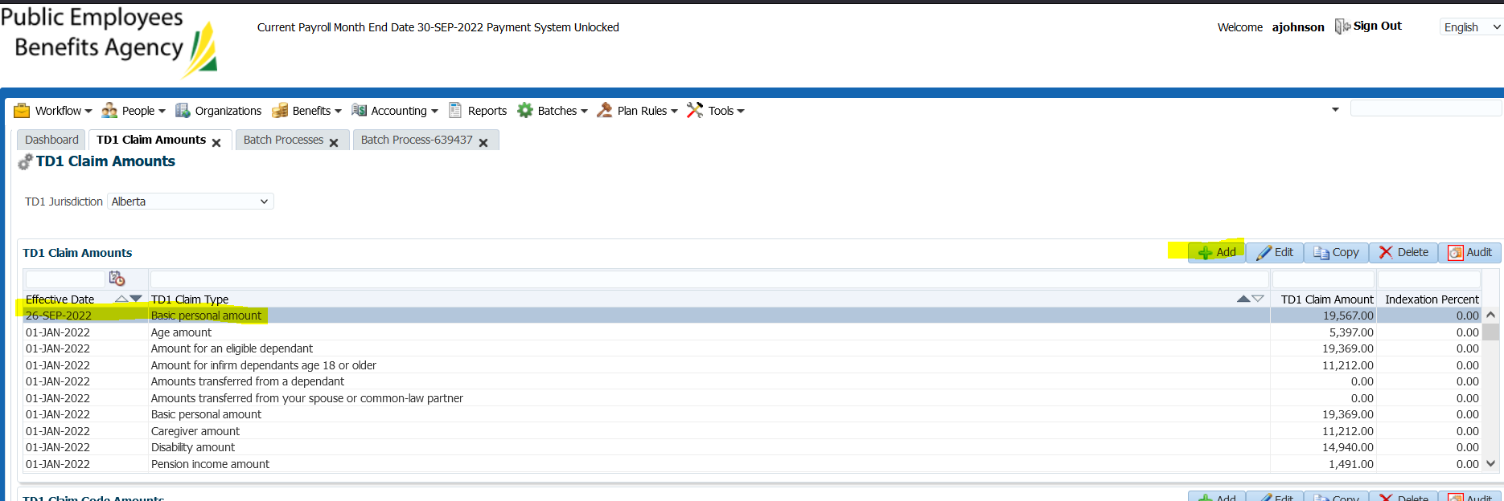

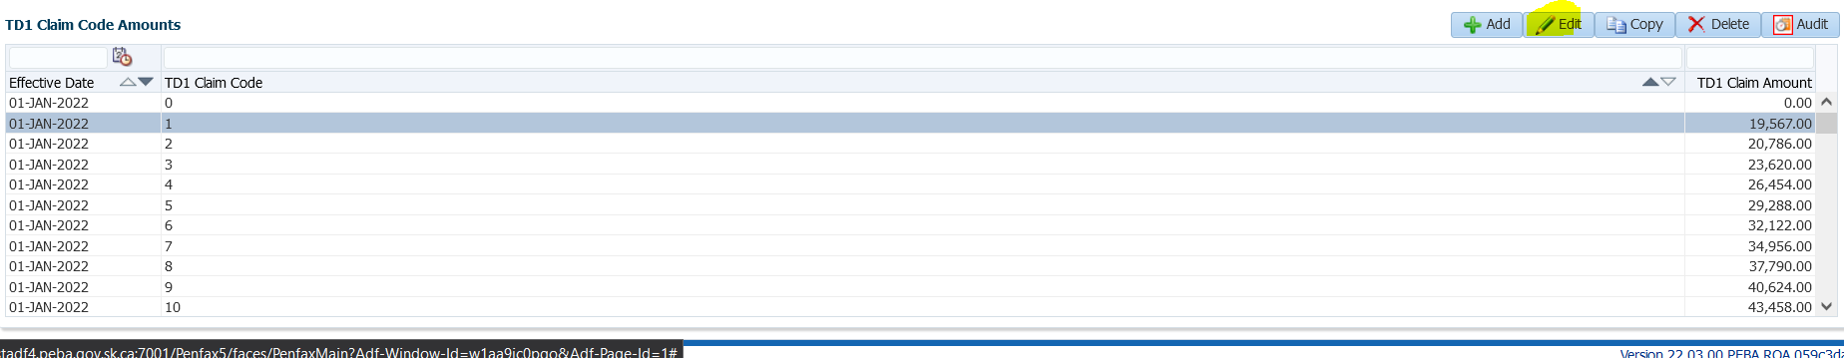

Saskatchewan:

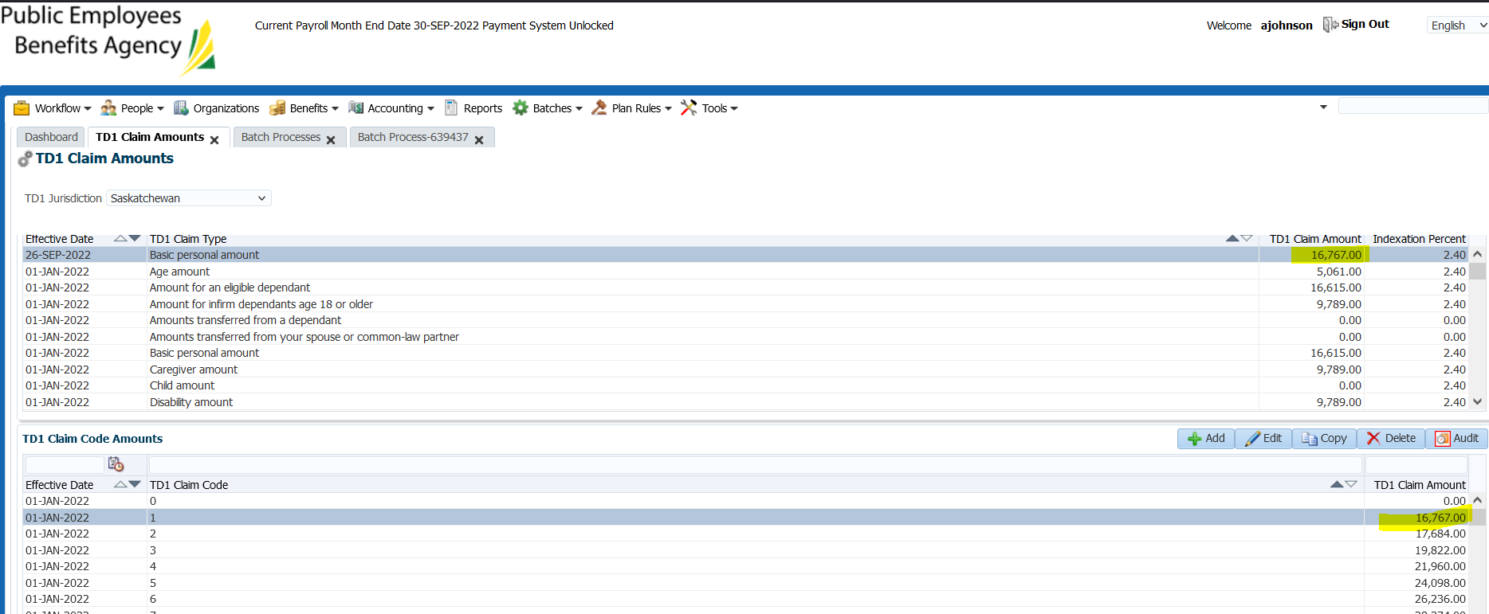

Federal (updated basic personal amounts):

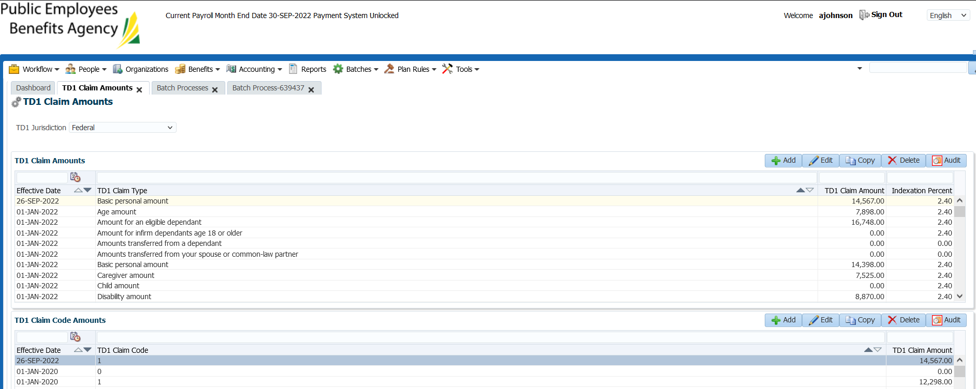

STEP 2:

Run Tax Indexation Batch:

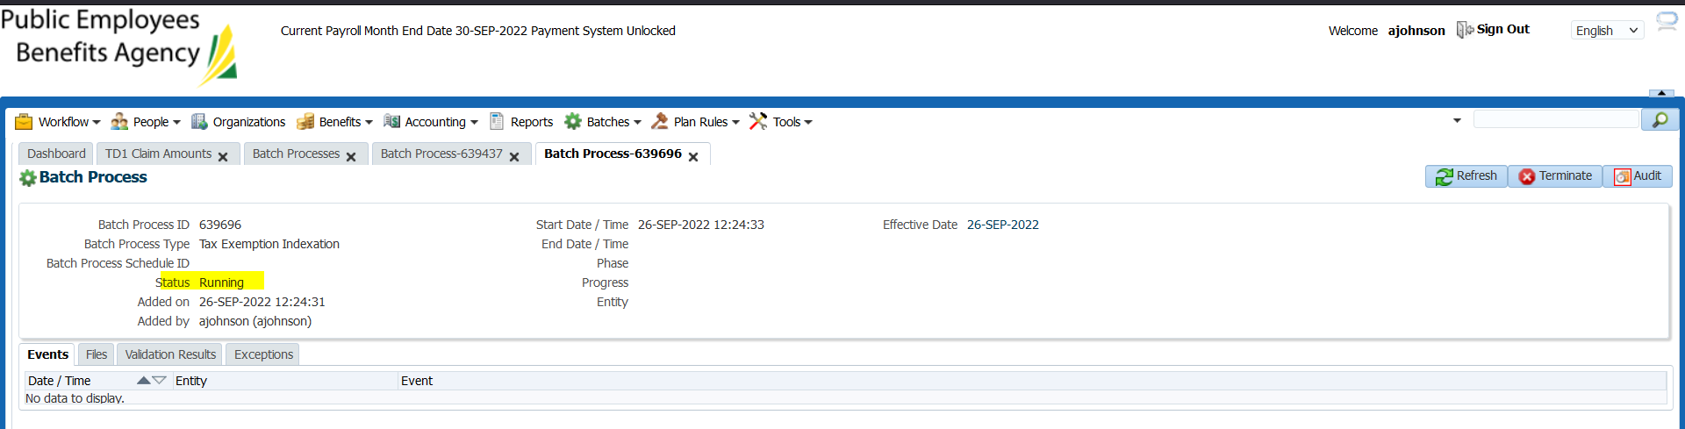

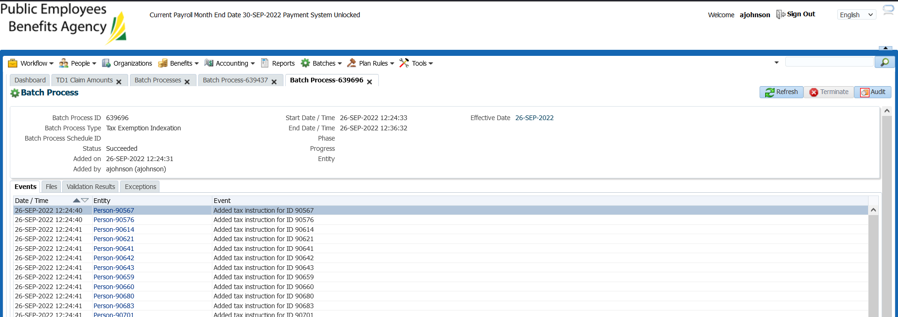

*the batch includes all PENFAX tax instructions (not just PEPP), found PEPP members in the list

SID 238514

Before:

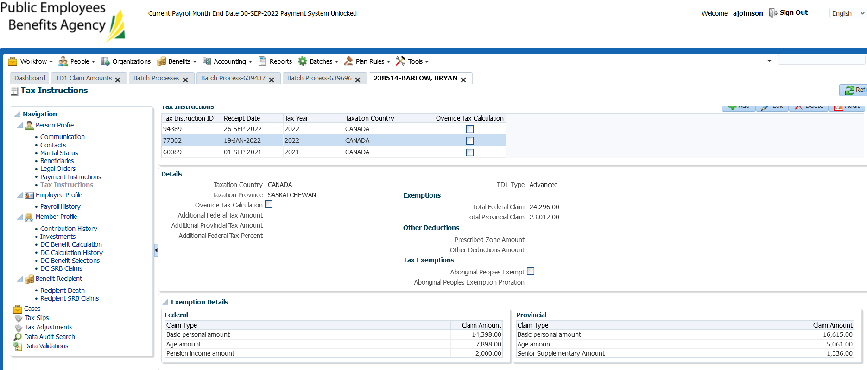

After:

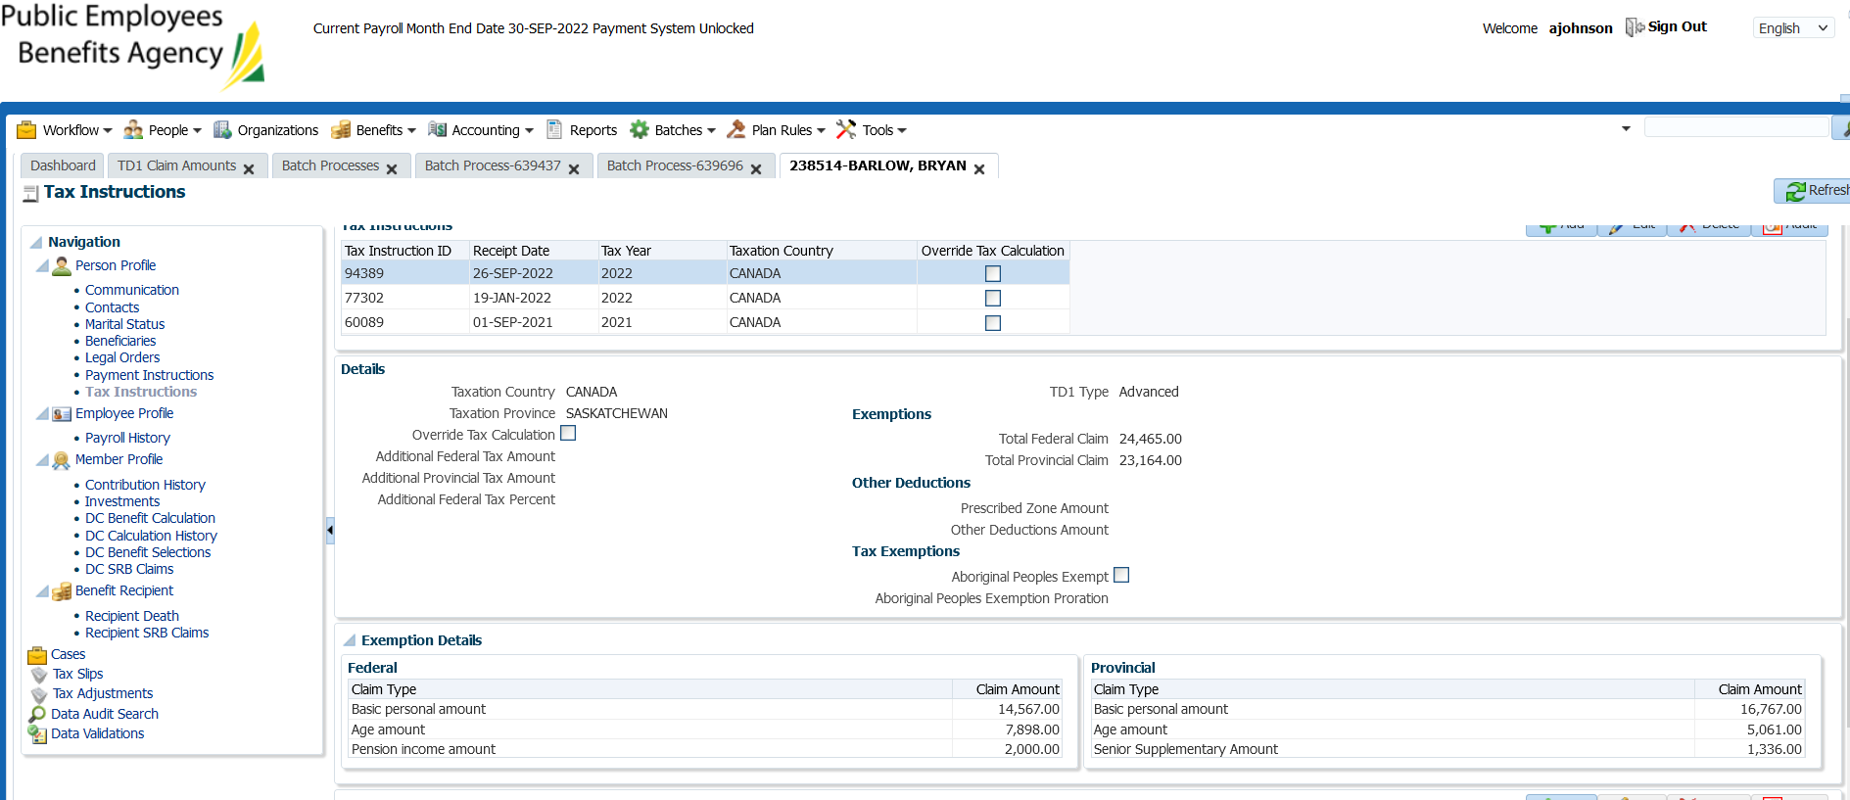

TD1 amounts were updated as previously updated in the TD1 claim amounts screen.

Benefit recipient also reflects the change:

Selected the retirement event type, income benefit type, and then clicked on the income benefit tab and looked at the tax instruction section.

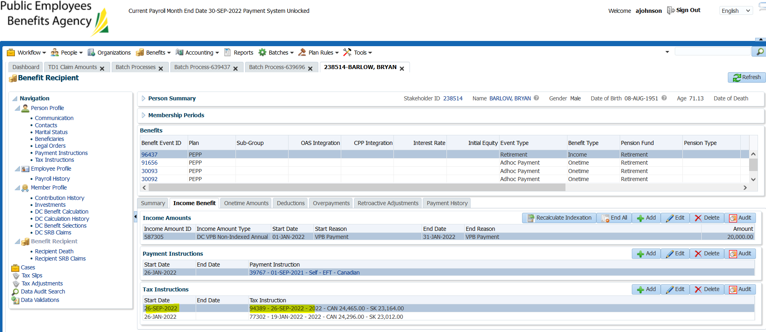

SID: 90614 – claim code not 0

Before:

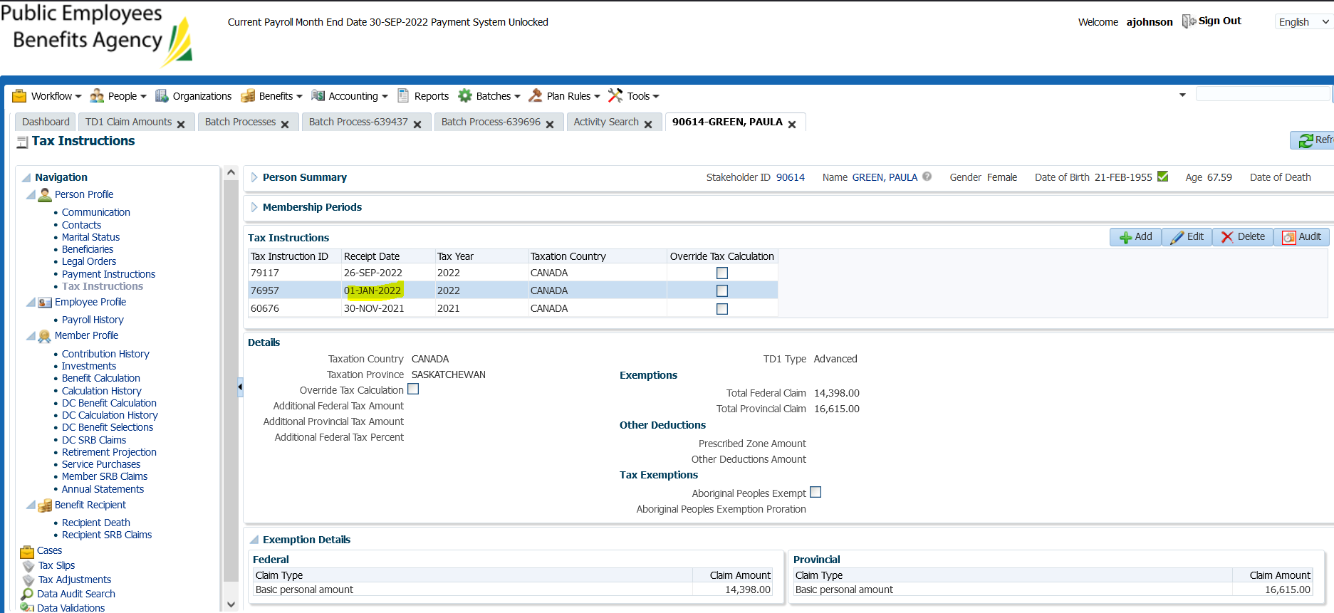

After:

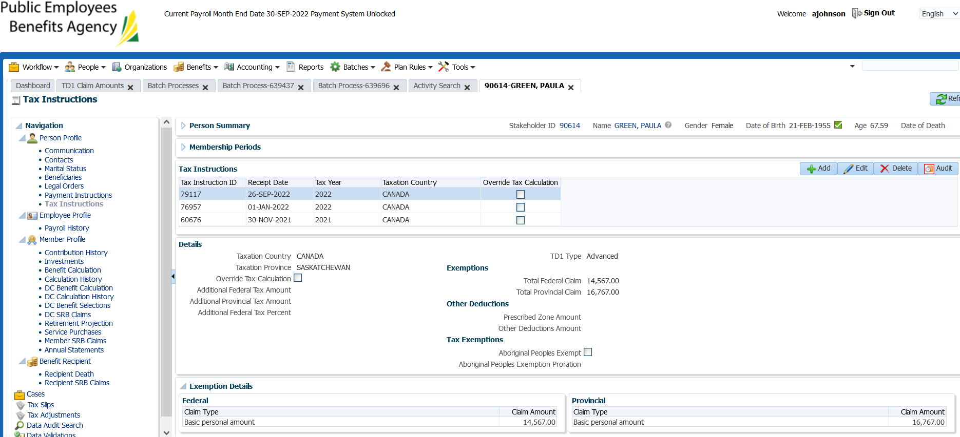

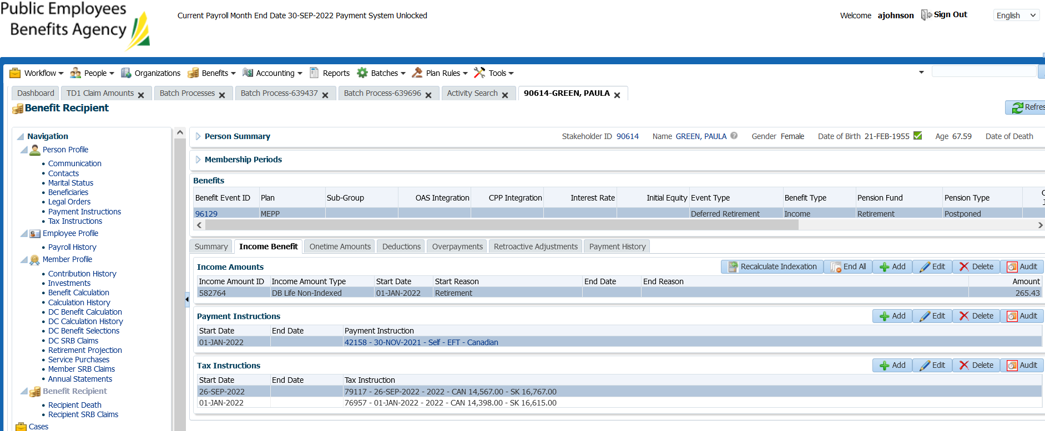

SID: 254136- additional tax

Before

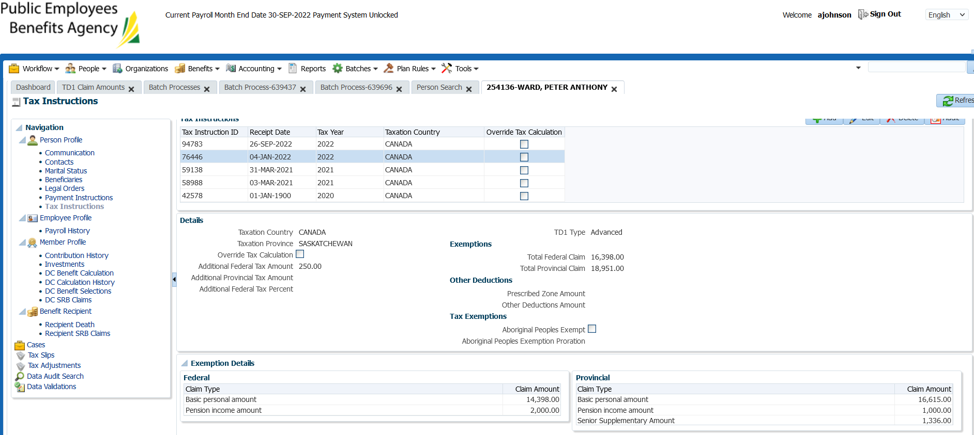

After:

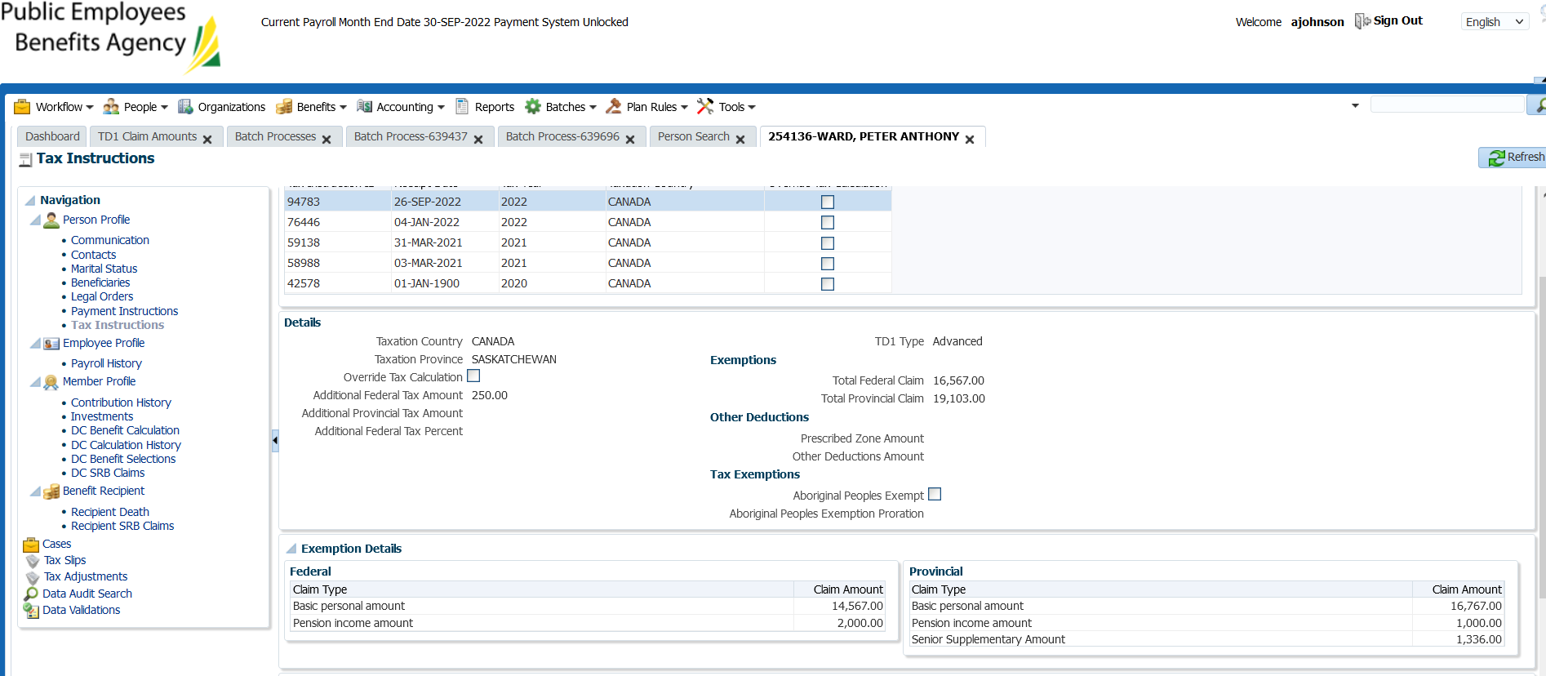

Benefit Recipient:

*\*checked to make sure there isn’t more than one plan.*

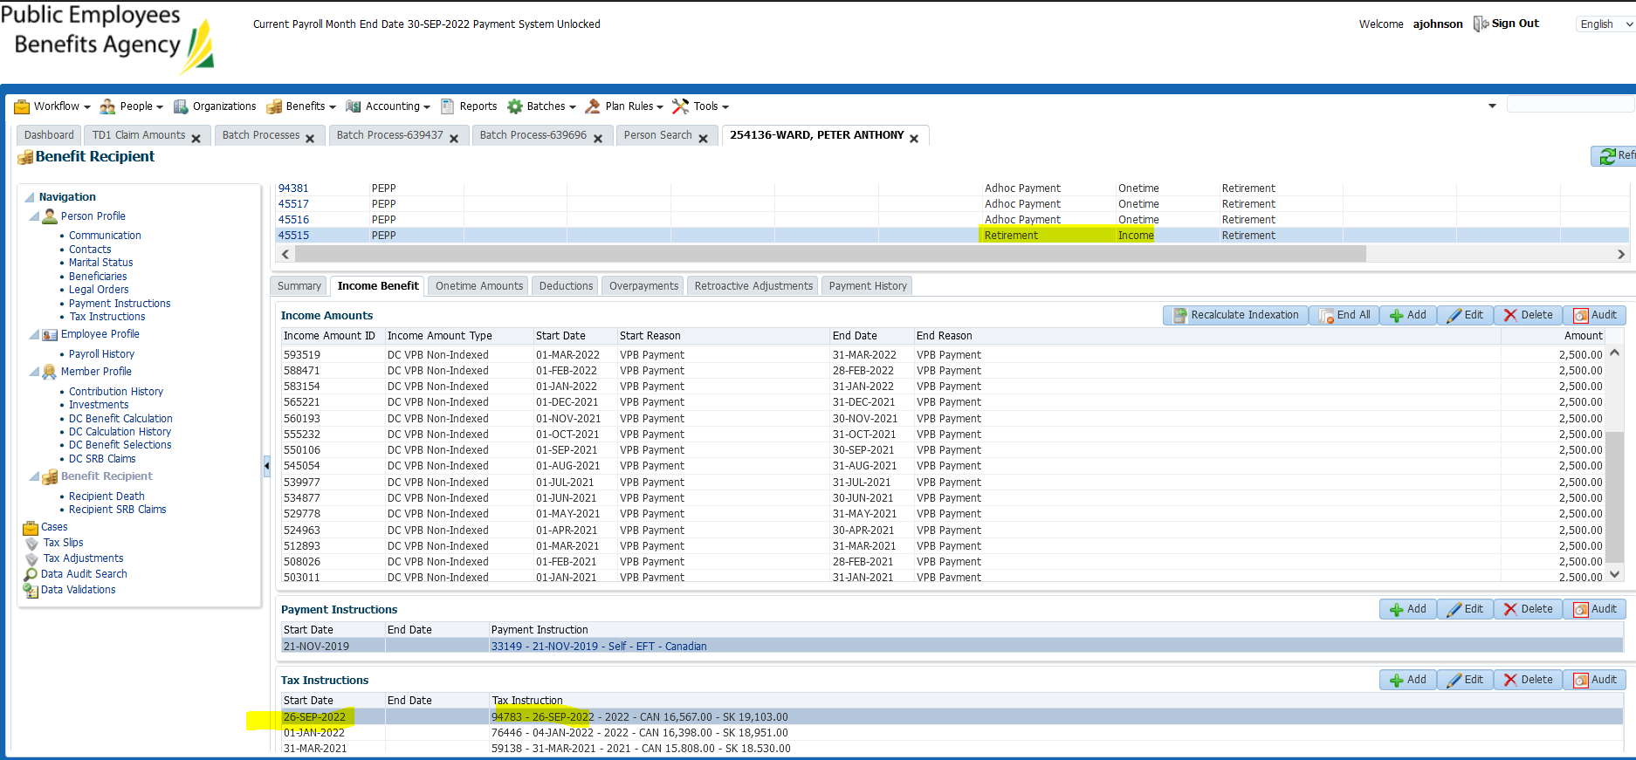

SID: 257976

Before:

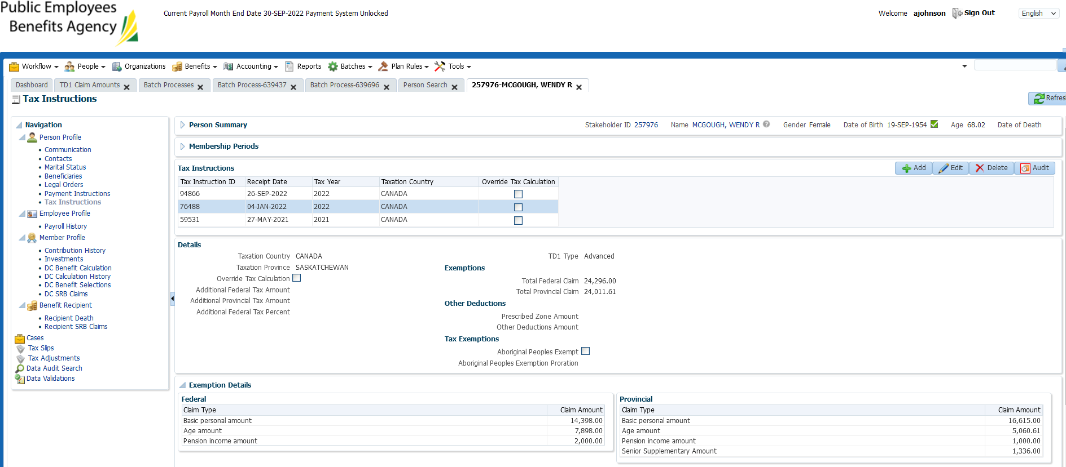

After:

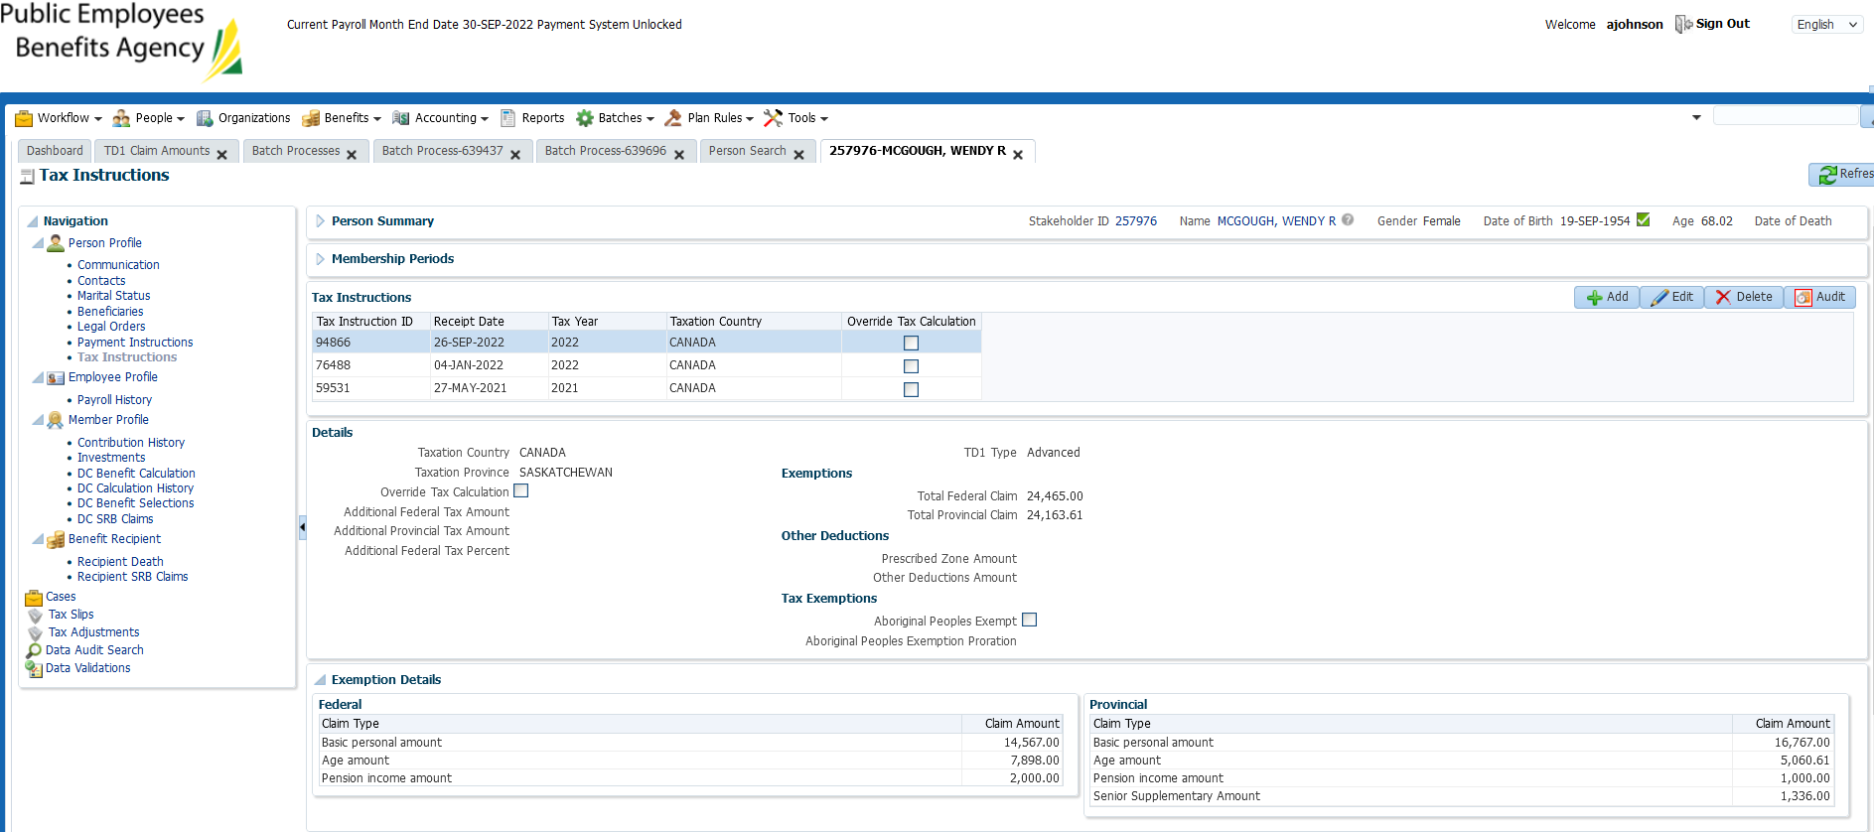

Benefit Recipient:

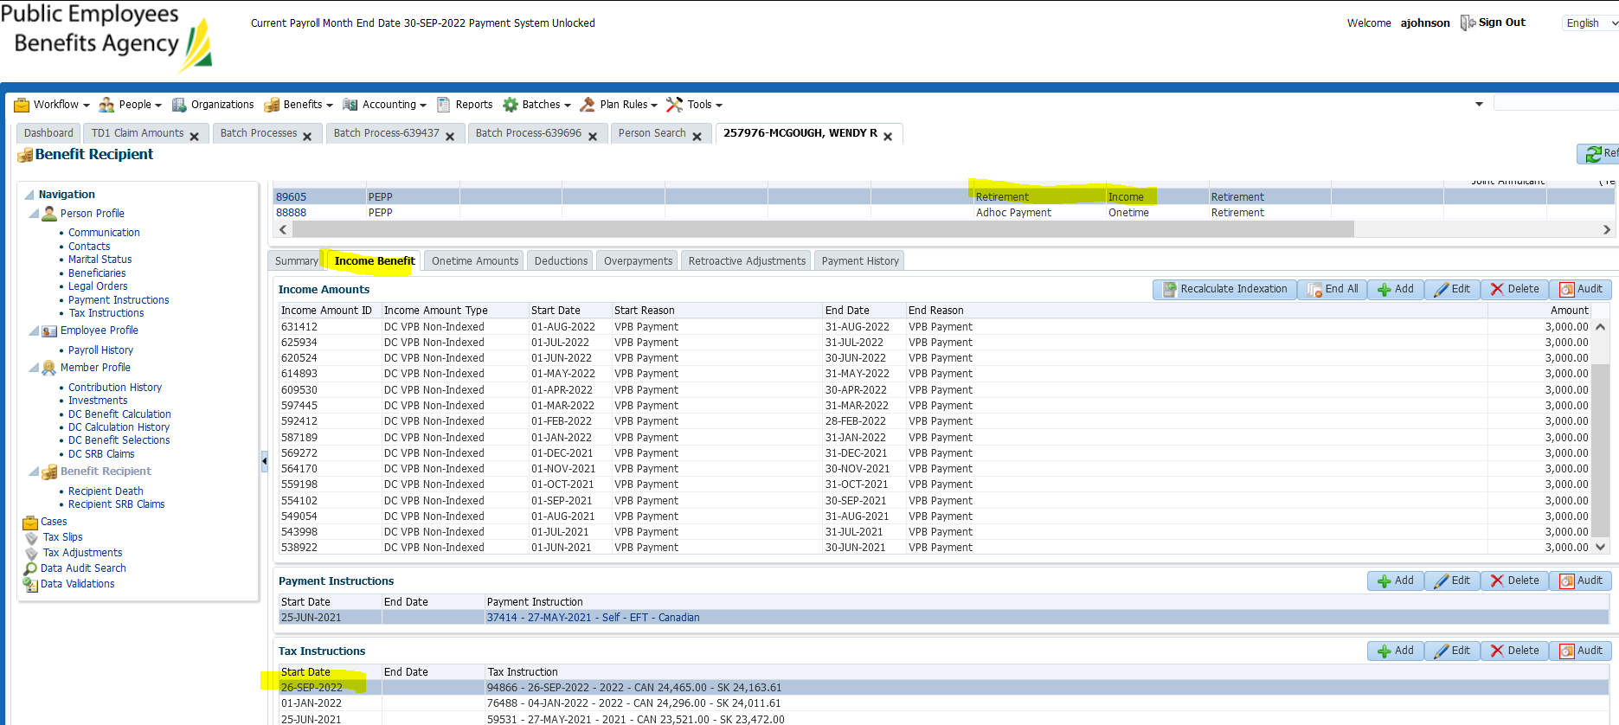

**23.04b**

SID – 197694 (more than one plan)

Before:

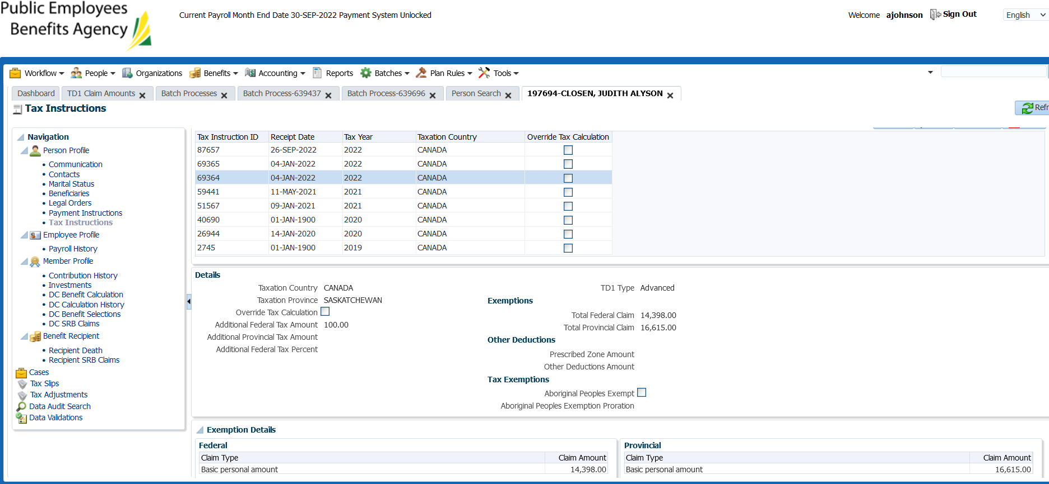

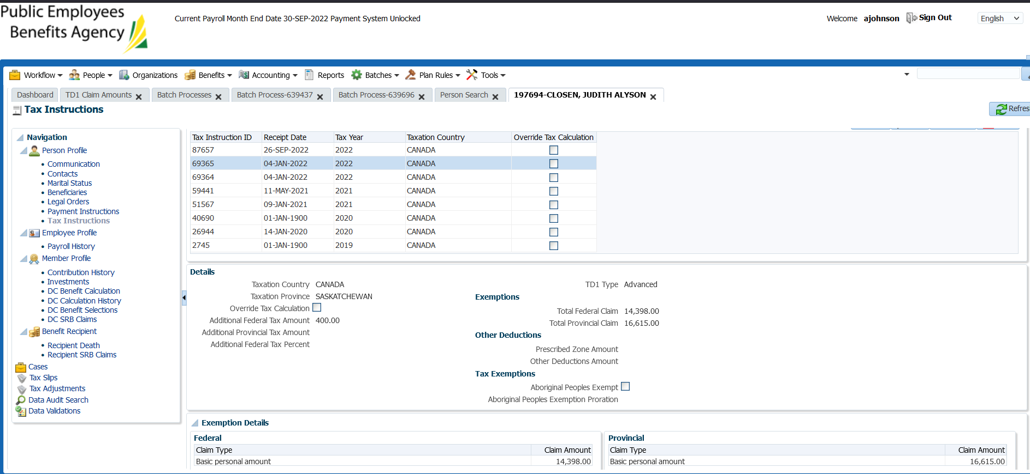

After:

*only one tax instruction created?

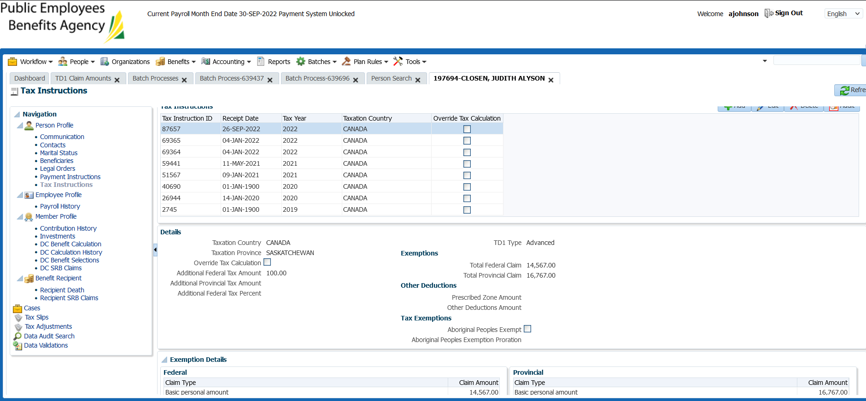

Benefit Recipient;

PSSP

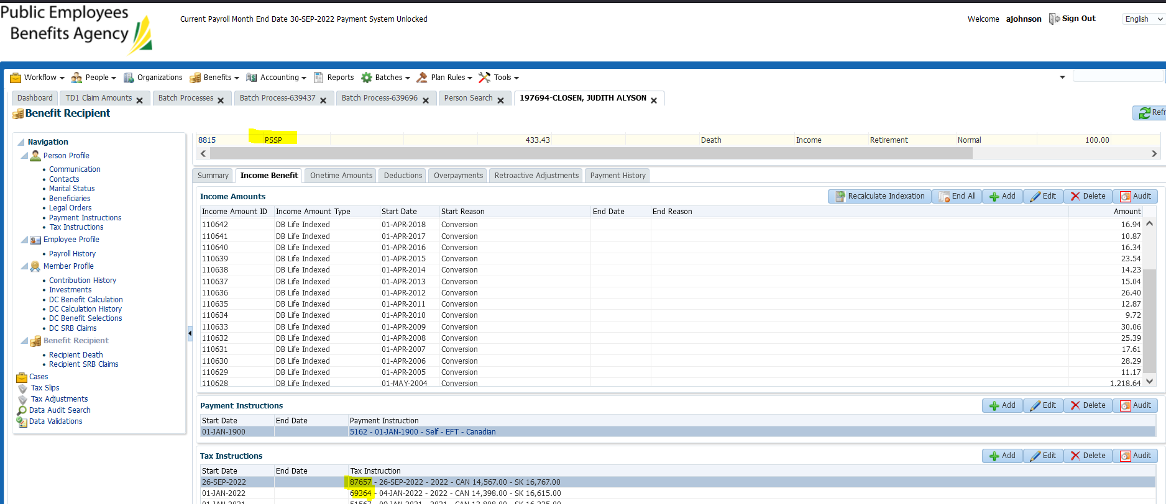

PEPP:

Tax instruction didn’t update as the balance is 0

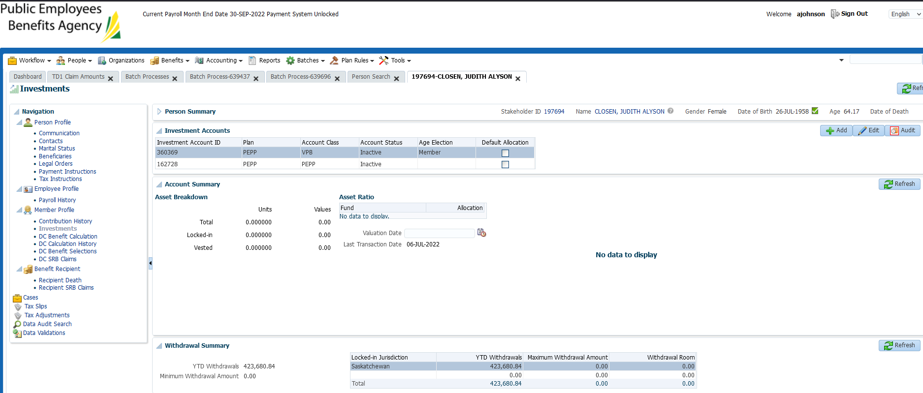

PSSP:

Tax instruction 69364 - $100 additional tax

New tax instruction 87657 - $100 additional

**SID: 274415**

No retirement/income benefit recipient (to find a member, check new VPB set up’s that don’t have a payment or pull report).

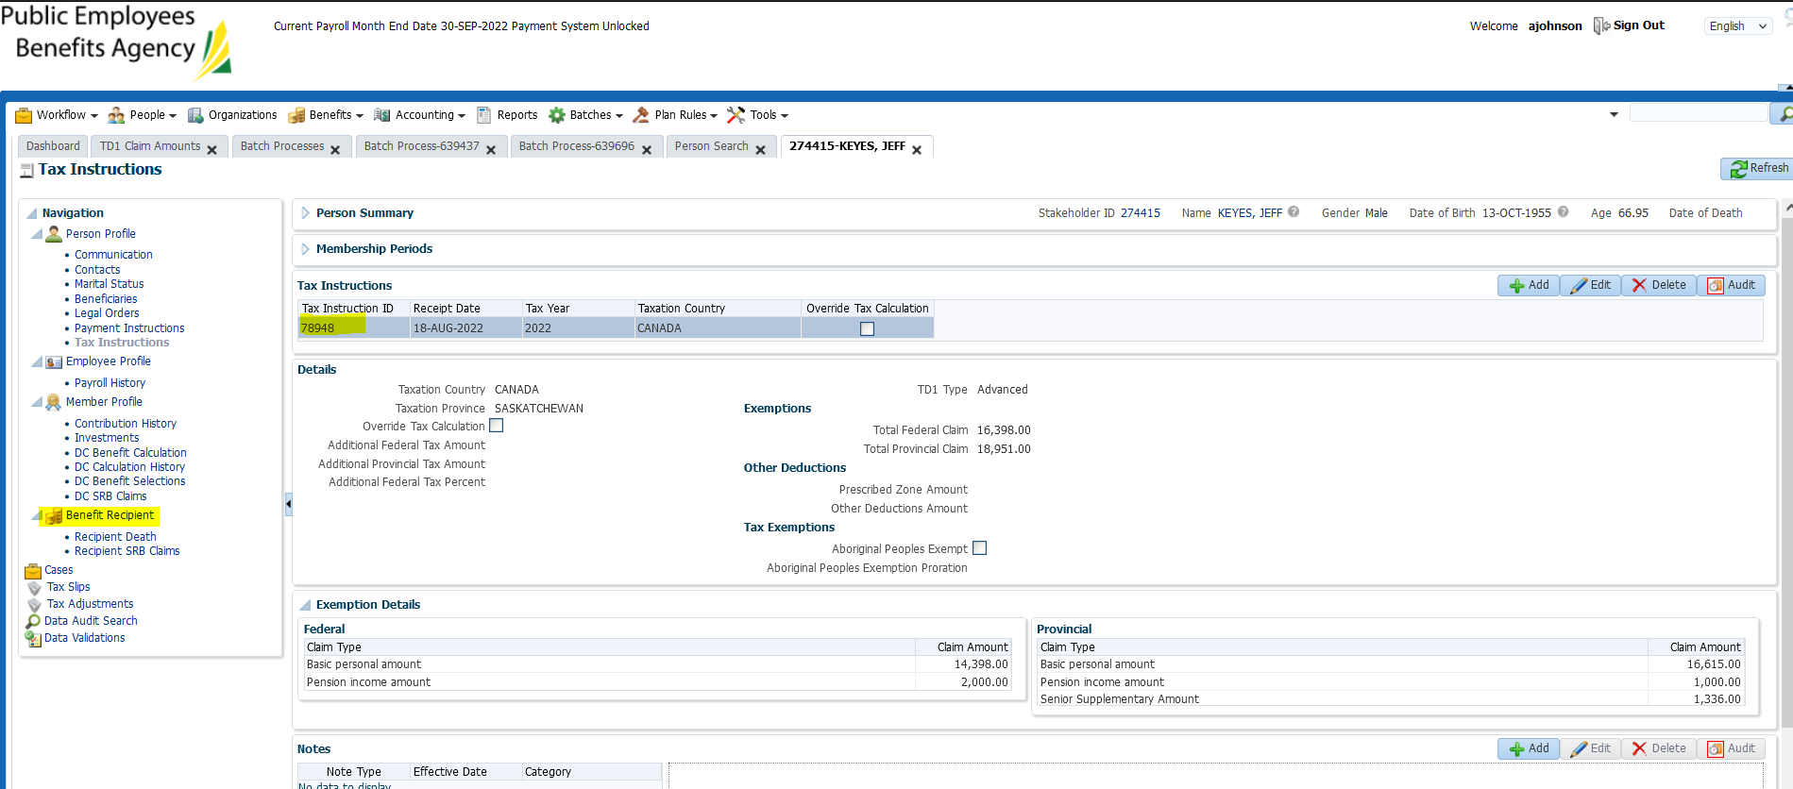

No retirement/income benefit recipient (eg. No scheduled payments have started yet but this member has taken out a lump sum payment from VPB):

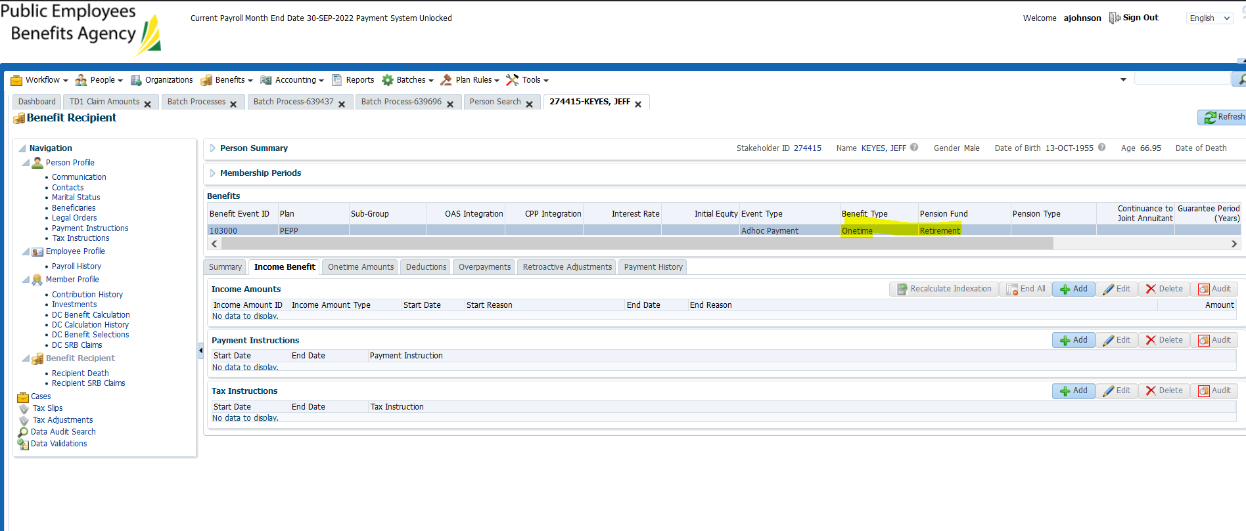

No new tax instruction created – FAIL

Checking an additional member

**SID: 243122**

Tax instruction created in Aug 2022 which is when the VPB was set up

No new Sept 26th instruction

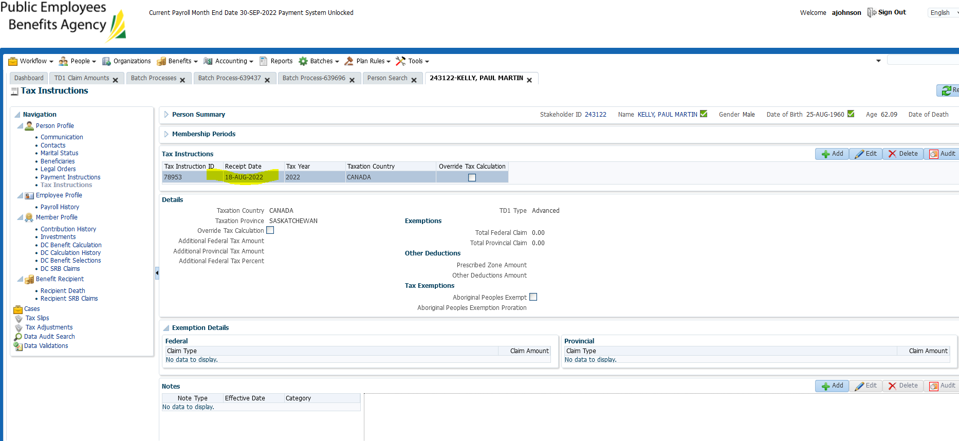

This one even has a retirement/income benefit recipient but claim code 0? Does claim code 0 need a date change in the TD1 screen in order to update – will test theory…

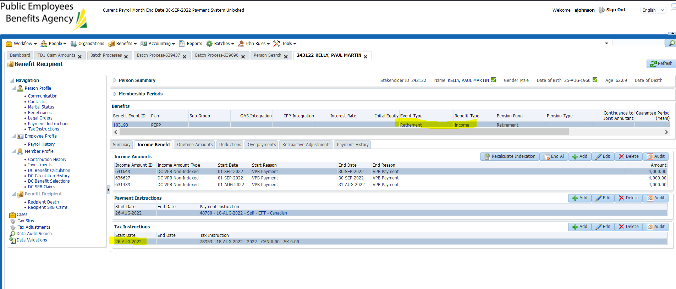

SID: 237701

Claim code 0 – tax update didn’t work??

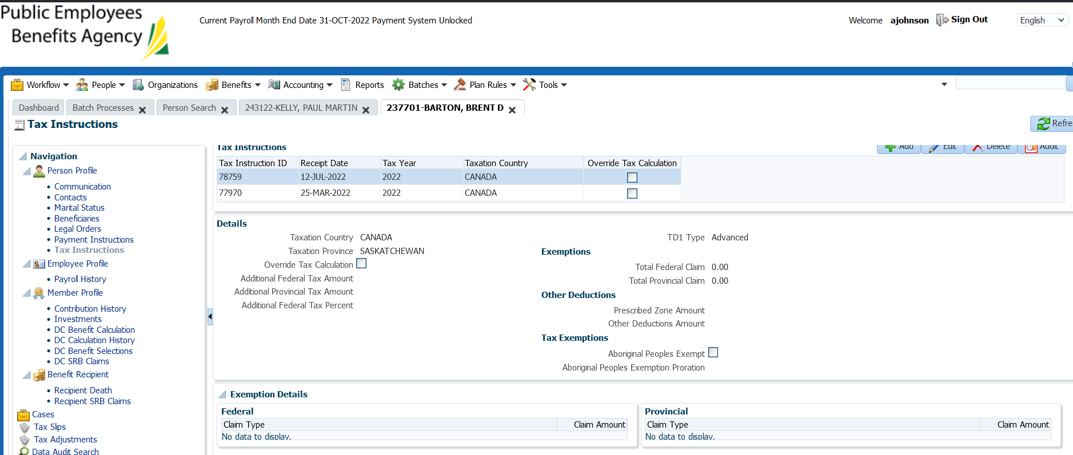

SID: 304992

Didn’t update?

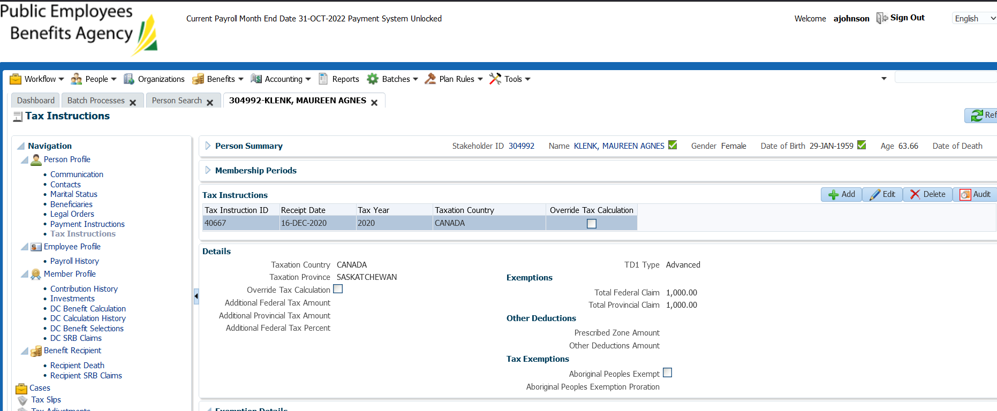

Updated Rates and re-ran tax batch:

Changed to 14.999 & 20.51110 in order to hopefully trigger the claim code 0 change

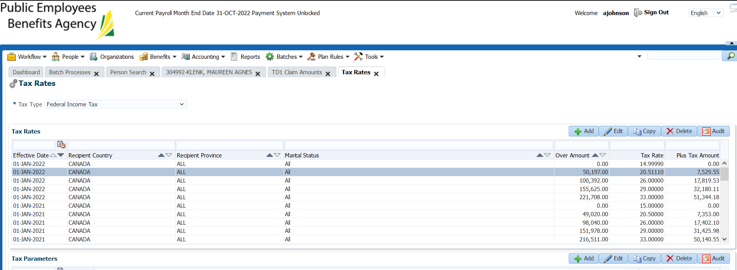

Re-stage test after refresh of Test 2: